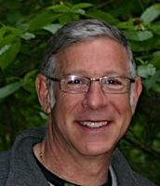

Did you know that Mr. Cohen, our PE teacher, is riding his bike from Vancouver to Seattle in support of the Cancer Foundation! His ride will take him 2 days and he will be riding approximately 130km per day for a total of 260km.

If you would like to support Mr Cohen’s incredibly challenging endeavour and make a donation to the Cancer Foundation, simply click on the link below and then click on DONATE ON LINE. It is easy and your donation will help to support research to conquer cancer for good.

All donations are tax deductable with receipts printable immediately on line.

Click on this link or copy it into your browser and you will get to Mr. Cohen’s webpage to make your donation

http://www.conquercancer.ca/site/TR/Events/Vancouver2011?px=2609189&pg=personal&fr_id=1371

Thank you to everyone for supporting Mr. Cohen and his RIDE TO CONQUER CANCER !!! For further information please speak to Mr. Cohen.

